Sponsorship Application Form

Company: … … … … … …
Contact: … … … … … … | Position: … … … … … …
Address: … … … … … …
… … … … … …
Postcode: … … … … … … | Country: … … … … … …
Telephone: … … … … … … | Fax: … … … … … …
Email: … … … … … …
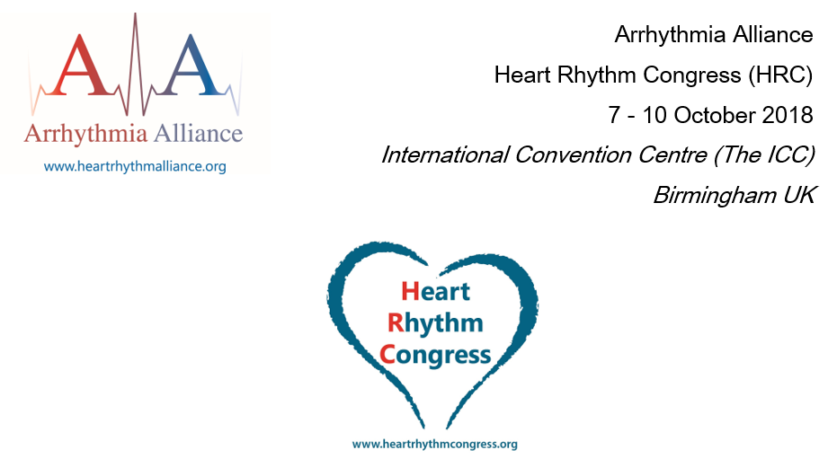
Invoice Address Details (if different from above)
Contact: … … … … … …
Address: … … … … … …
… … … … … …
Postcode: … … … … … … | Country: … … … … … …
Telephone: … … … … … … | Email: … … … … … …
Please tick the appropriate box and if appropriate, select quantity required:
Exclusive Sponsorship
(✔) | Item | Price
 | Delegate Folders | £3000
 | Lanyards | £500
 | Delegate Badges | £500
 | Notepads & Pens | £900
 | Lunch Bags | £500

On-site Advertising
(✔) | Quantity | Item | Price
 | Select... | Stair Signs | £65 per step
 | Select... | External Door Graphics - (Max.16 panes) | £155 per pane or £80 per strip
 | Select... | Directional Banners | £90-£200 (by location)
 | Select... | Gobo (new design – includes production & location) | £300 per design or £150 for all designs purchased prior to HRC2018
 | n/a | Media Wall Slide | From £315-£900 (by size & duration)
 | Select... | Gallery Banner | £750 each
 | n/a | Registration Desk Headers | £855
 | Select... | Information Screens | £3000 (all screens for 3 days)
 | Select... | Mall Monoliths | £500 (per slide for 3 days on two screens)
 | Select... | Mall Banners | £1000 (per pair)
 | n/a | 7m x 7m Mall Banner | £7000

E-reach
(✔) | Quantity | Item | Price
 | n/a | Personalised Email Advertisement | £400 per email (Max 4 slots available)
 | Select... | Mobile App Advert | £500
Cancellation Policy
All cancellations of sponsorship items should be sent in writing to k.fensom@heartrhythmcongress.org.uk Cancellation fees of 100% apply once a signed sponsorship application form has been received.

By signing this form I confirm I have read and agreed to the policy set out above.

Signature: | Date: Enter date here...

