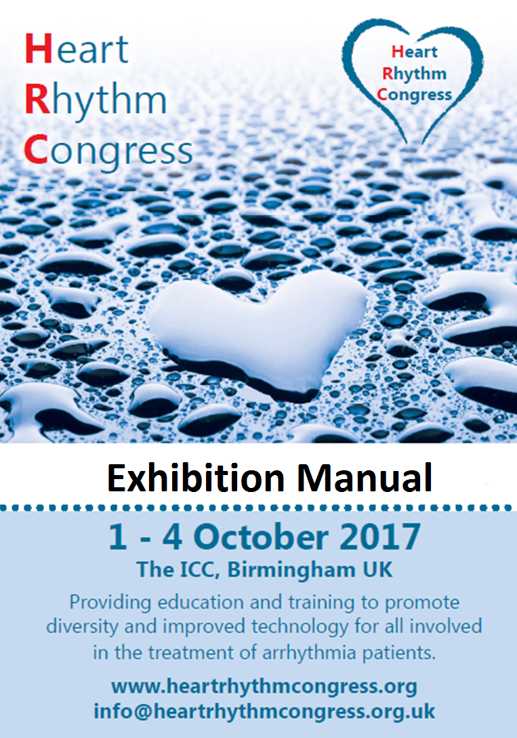

Dear HRC Exhibitor

This document contains important information and is designed to help you prepare for Heart Rhythm Congress (HRC) 2017, providing all the information that will be useful to you as an exhibitor. Please ensure you read the details carefully and distribute to all parties involved with the congress.

If you have a query regarding an item that is not mentioned within this manual or if you require further information please get in contact and a member of the HRC team will be happy to assist you.

All related attachments can be found on our website.

We look forward to welcoming you to the 12th Heart Rhythm Congress, at the International Convention Centre (The ICC), Birmingham UK.

Kind regards

Becky Bell
Events Manager
Arrhythmia Alliance – The Heart Rhythm Alliance

Contents

Page

- General Information 3

- Exhibition Information 4-6

- Technical Information 6-8

- Additional Items 8-11

General Information

Contacts

HRC Organiser  Becky Bell  +44 (0)1789 867524  becky@heartrhythmcongress.org.uk | Official Exhibition Contractor, Dimension 8 Ltd  Jon Porter  +44 (0)1633 270808  jon@dimension8.com
Event Manager, The ICC  Anna Jones  +44 (0) 121 644 5064  anna.jones@theicc.co.uk | Event Manager - Technical, The ICC  Ben Prior  +44 (0) 121 644 5135  Ben.prior@theicc.co.uk
Food & Beverage Manager, The ICC
Adrian Santos Calvo
+44 (0) 121 644 6164
adrian.santos@theicc.co.uk

Congress Dates & Venue

Dates 1 - 4 October 2017

Venue International Convention Centre (The ICC)
Broad Street
Birmingham
B1 2EA
Please note: It is the responsibility of the exhibitors to ensure that contractors are familiar with the rules and procedures of the exhibition.

Exhibition Information

- Timetable

 | Date | Time
Deliveries to Venue | Friday 29 September | 09:00 – 17:00
Stand Build (Platinum & Gold) | Sunday 1 October | 06:30 – 22:00
Stand Build (Silver) | Sunday 1 October | 11:00 – 22:00
Set Up (Bronze) | Sunday 1 October | 18:00 – 22:00
Exhibition Opening Hours | Monday 2 October | 09:30 – 18:45
 | Tuesday 3 October | 08:00 – 18:15
 | Wednesday 4 October | 08:00 – 13:30 – registration foyer exhibitions only.  The main exhibition hall will be closed
Stand Breakdown | Wednesday 4 October | 07:00 – 15:00 if you are in the main exhibition hall  14:30-16:00 if you are in the registration foyer

Please note:
- All stands must be built/broken down by the times specified; there will be no flexibility for extra time
- If your stand is in the registration foyer, please note delegates will have access to this area from 07.30 each morning including the Wednesday. The Main Exhibition Hall will be closed on the Wednesday.

- Deliveries

Deliveries for stand and booth materials/accessories will be accepted on Friday 29 September and not before. Please ensure you use the event Delivery Label and include your stand name and number.

- Access

On stand build day Bay A provides access to Hall 3 (see Loading Bay Access Map).

- Dismantling

Dismantling of stands and displays must not commence until after the exhibition has closed and is cleared of delegates.

If you arrange for couriers to pick up goods, please ensure that all items to be collected are packed away by company employees and clearly labelled with the Collection Label. All unlabelled materials left behind after Wednesday 4 October will be disposed of.

- Insurance

Neither the HRC Organisers nor The ICC will accept responsibility for damage or loss of goods or bags left in the venue prior to, during or after the exhibition. All goods and bags belonging to companies must be claimed and removed from The ICC at the close of HRC.

- Risk Assessment

All exhibiting companies must read, complete and return The ICC’s Risk Assessment Checklist. All exhibitors are also required to produce their own Risk Assessment for the activities they intend to undertake whilst at the exhibition. This should include all possible hazards on your stand. Please submit your Risk Assessment Checklist and Risk Assessment to becky@heartrhythmcongress.org.uk

If you have purchased a Platinum or Gold space you must ask your appointed contractor to complete the Construction, Design and Management (CDM) Roles Pro-forma outlining who is the client, principle designer, principle contractor and any other contractors involved. Descriptions of the roles and responsibilities of the positions included in the pro forma
can be found here. Please submit your completed Construction, Design and Management (CDM) Roles Pro-forma to becky@heartrhythmcongress.org.uk

- Venue Care

No attachment, fitting, fixture or defacement is to be made to the flooring, ceilings, internal or external walls of the building. Exhibitors are reminded that they will be required to pay for all damages.

Technical Information

- Hall Access Policy

During the exhibition build and breakdown, everybody in the effected space must wear high visibility clothing and appropriate protective footwear as a minimum. If overhead work is taking place, hard hats must also be worn. Read the full hall access policy here.

- Shell Scheme Stands

Silver stands are provided as part of a shell scheme.

A shell scheme booth will consist of:
- 3-side white Foamex wall partitions (this reduces to 2 partitions if your stand is at the end of the stand block)
- Fascia board with company name on open sides (see additional items)

See attachments for Shell Scheme Specification. If you would like to add to the standard shell scheme build, this can be ordered through our exhibition contractor, Dimension 8 Ltd. Password: HRC2017

- Space Only Stands

Platinum and Gold stands are provided as a space only option. The exhibiting company must arrange their own build arrangements and a copy of the booth plans (including dimensions) and your contractor’s details should be sent to Becky Bell for approval by Friday 4 August.

- Height Restrictions

Platinum and Gold Stands must not exceed 4m height.
The height restriction for shell scheme stands is 2.5m; this height restriction must be adhered to where any graphics, furniture or other builds are concerned. Please be aware the visual height with a fascia name board is 2.3m.

- Lifting & Handling

If you require a forklift to assist in unloading/loading your stand on the build-up or break down days, this must be booked in advance. Charges apply. Please contact Becky Bell for further information.

- Electrics

Electricity is not part of your stand package. Electrics can be ordered through our exhibition contractor, Dimension 8 Ltd via their online ordering system. Password: HRC2017

Deadline for electric orders: Friday 8 September.

Please note: The electricity for the exhibition will ONLY be connected after being checked and approved by the official exhibition contractor.

- Flooring

All exhibition surfaces are carpeted. If you would like to order a specific colour of carpet, please visit www.dimension8.com

- Suspended Structures

If you would like to suspend a structure above your stand please contact Becky Bell. Charges apply. Deadline for rigging requests: Friday 15 September

Additional Items

- Audio Visual

Audio visual equipment for your stand can be provided by The ICC.

Ordering is quick and easy via their 24/7 online ordering system with payment being made via a secure card payment system. To place an order visit: www.theicc.co.uk/the-exhibitor/online-ordering Pass code: 54889

- Internet Access

Free Wi-Fi access will be available in all public spaces of The ICC. However if you require Internet access for stand operations, this must be purchased separately through The ICC Online Ordering System. Pass code: 54889

- Furniture

Furniture is not included with your stand (with the exception of table top packages which includes a table, table cloth and two chairs). Furniture hire can be arranged by The ICC via their 24/7 online ordering system. www.theicc.co.uk/the-exhibitor/online-ordering Pass code: 54889

Please note: it is not compulsory to order your furniture through The ICC – you may choose to bring your own.

- Stand Catering

Stand catering (food, drink, and equipment) can be purchased directly from HRC by contacting Becky Bell

If you are planning on having any food or beverages served from your stand, please note prior permission needs to be obtained from The ICC. For all catering enquiries, please contact Becky Bell

- Fascia Name Board (only applicable to shell scheme exhibitors)

A fascia name board will be positioned on the top of each open side of your stand detailing your company name and stand number. To provide your company name for your fascia board click here.

If you do not want your shell scheme stand to be set up for a fascia name board, please contact Becky Bell.

- Passes

All exhibitors are required to be registered at HRC. Additional staff passes can be purchased for £240 +VAT; this is for the duration of the congress and includes:

- Admission to exhibition
- Lunch and refreshments
- Access to congress sessions

Deadline to order additional staff passes: Monday 25 September.

Please note that all payments for passes must be received before Thursday 28 September.

- Stand Activities
You must make HRC aware of any stand activities you are planning, for example presentations, interactive demonstrations. You will need to send an outline of your plans including the intended date and time to Becky Bell.

- Meeting Rooms & Industry Events

If you require a room to host an innovation suite or you would like to book a meeting room for another purpose, please get in contact to discuss your requirements.

Please note: industry meetings with presentations for HRC delegates outside the official scientific programme are strictly forbidden. HRC allows companies to hire a range of rooms available within the congress centre for small and informal meetings.

- Accommodation

We have an official booking agent, Brief2Event Solutions who can deal with all of your accommodation needs. Instructions for booking can be found here.

- Promotional Opportunities

There are a number of promotional opportunities on offer to maximise your exposure at the congress including delegate folders, on-site advertising, agenda adverts and personalised email advertisements.

For further details, take a look at pages 6-9 of our exhibition brochure.

- Awards & Reception

This event will be taking place on Monday 2 October at The ICC; the evening will include a drinks reception in Hall 3, followed by awards and a buffet supper in Hall 4. Tickets are required for the awards and buffet supper and cost £15 each; to book or for further information please contact: info@heartrhythmcongress.org.uk / +44 (0) 1789 867523.

